**In my Online Grocery Store, it consists of the following entities:**

**1.Supplier :**

Suppliers are those who are supplying the beauty products. In this entity we store different attributes like supplier Id, Supplier Name, Supplier beauty product, Average Date to supply.

The attributes involved are

* Supplier_ID: integer- It is to store the supplier ID and act as a primary key. In case if we want to find what products are supplied by the particular Supplier, we can search by Supplier ID.
* Supplier_Name : string- It is for the name of the suppliers
* Product_Item: String - What Grocery products are supplied by suppliers.
* Average_Date_to_supply: Date – Average date to supply the products by the supplier.

**2. Online_Grocery_store:**

This entity stores the different types of Grocery products which the store produces.

* Grocery_Product_ID:int - It stores the unique Id for the different Grocery product types. It acts as a primary key.
* Grocery_Product_type:string – It contains the different Grocery product types like food,Beverages and Snacks which the store produces.
* Product_Name:string- It stores the name of the product.
* Product_Details: string -It describes the details of the product.

**3. Customer:**

This entity stores the details of the customer.

* Customer_ID:int – It stores the ID of the Customer.
* FirstName: string – It stores the First Name of the customer.
* LastName:string - It stores the Last Name of the customer.
* Address: string – It stores the address of the customer.
* Mail_ID : string – It stores the Mail ID of the customer.
* Phone_Number:int – It stores the mobile number of the customer.

**4. Sales:**

This entity stores the information regarding Sales.

* Sales_ID:int – It stores the ID of the Sales.
* Sales_Quantity: int – It contains the sales of the product based on the quantity.
* ProfitAndLoss:float - It stores the profit and loss.
* Product_Instock: Boolean – It tells whether the product is in stock or out of stock.
* Month:int- It tells in which month the sales are about.
* Monthly_Sales:int – It stores the monthly sales of the store.

**5. Order:**

This entity stores the details of the order.

* Oredr_ID:int – It stores the ID of the Order. Customers can track their order by order ID.
* Product_Price:float – It stores the price of the product.
* Quantity:int – It stores the quantity of the product selected by the customer.
* Total_Price: It tells the total price the customer purchased.
* Payment_details:string - It stores the details of payment.

**6. Payment:**

This entity stores the details of the payment.

* Payment_ID:int – It stores the ID of the Payment.
* Cash_On_Delivery: boolean – True if the customer paid by cash on delivery or else False.
* Credit Card:boolean - True if the customer paid by credit card or else False.
* Debit Card: boolean – True if the customer paid by the debit card or else False.
* InternetBanking:Boolean - True if the customer paid by the internet banking or else False.

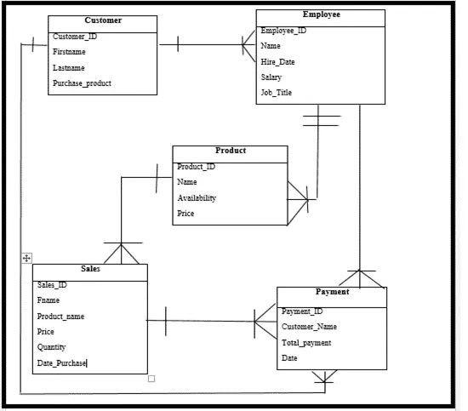

**Github URL**

**::https://github.com/bharath4568/project-.git**